In the following diagram we can see the state chart that talks about a Client, Server/Network, a Sensor, Logs (Data), Administrator, an IDS and an Intruder.

Here, we are going to secure a data from Intruder.

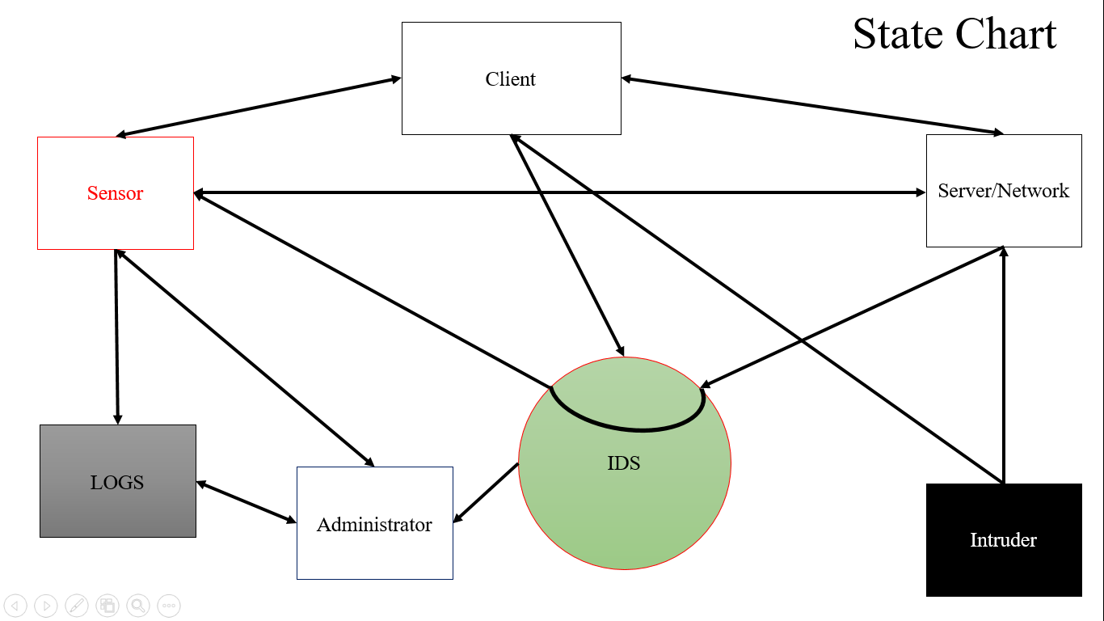

In this diagram we can see every data is connected to agent and administrator.

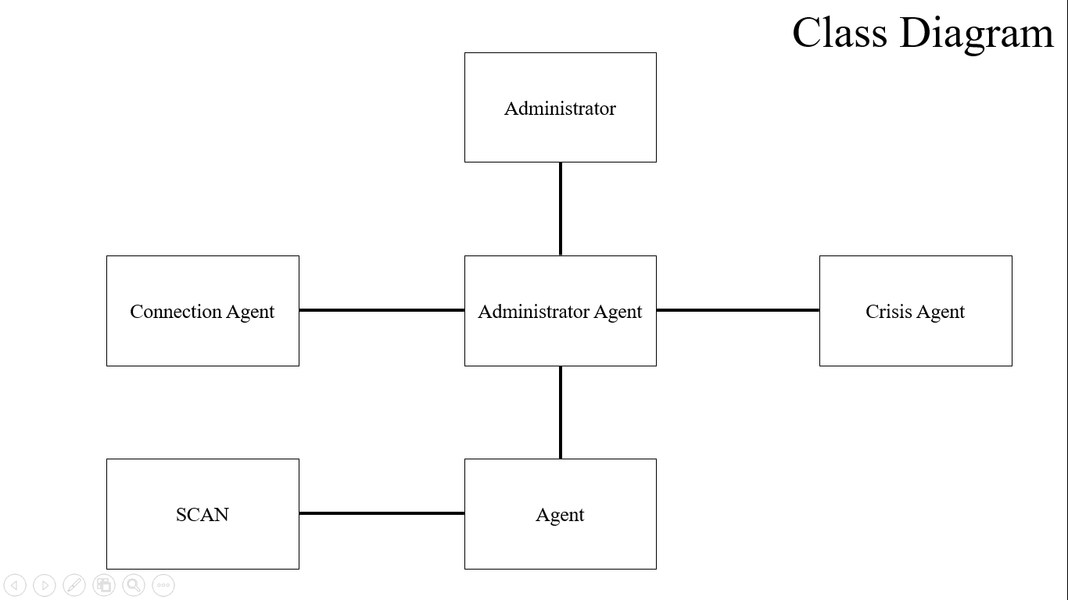

In this diagram, we can see the data is online and offline, and an attacker will try to access to the information and the sensor inform to the administrator to update and change the information and send further.

